📊 Exploratory Data Analysis (EDA) Report
🏢 B2B Transaction Business

1. 📌 Objective of Analysis
The main objectives of this analysis are:
- To understand overall sales performance
- To analyze customer behavior, products, and orders
- To identify key business patterns and trends
- To support decision-making in inventory, marketing, and operations
- 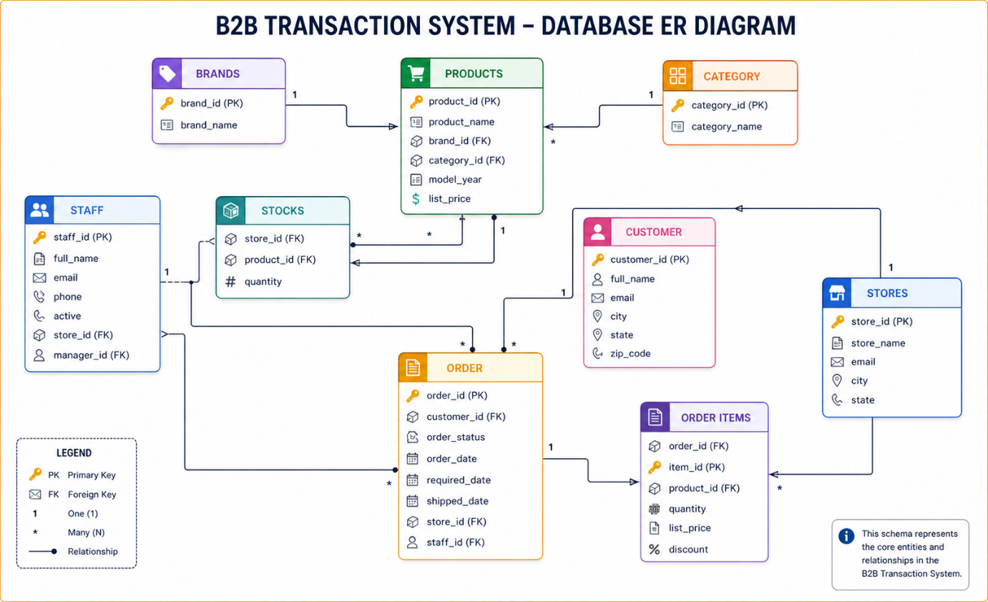

2. 🗂️ Data Overview
Table Name | Rows | Key Columns
Brand | 9 | brand_id
Category | 7 | category_id
Customer | 1445 | customer_id
Orders | 1000+ | order_id
Order Items | 999+ | order_id, product_id
Product | 321 | product_id
Staff | 10 | staff_id
Stock | 939 | product_id, store_id
Store | 3 | store_id

3. 🔗 Data Relationships
- Customer → Orders (One-to-Many)
- Orders → Order Items (One-to-Many)
- Product → Order Items (One-to-Many)
- Brand → Product (One-to-Many)
- Category → Product (One-to-Many)
- Store → Orders & Stock
- Staff → Orders
👉 These relationships form a star schema-like structure, enabling efficient analysis.

4. 🧹 Data Cleaning Checks
Before performing analysis, the following checks are required:
✔ Missing Values
- Customer email may contain missing values
- Delivery date may be null for pending orders
✔ Data Types
- Date columns → Convert to proper date format
- Price → Numeric format
- Discount → Percentage/decimal format
✔ Duplicates
- Check duplicates in:
  - Order IDs
  - Product IDs

5. 📈 Key Metrics
💰 Sales Metrics
- Total Revenue = Quantity × List Price × (1 - Discount)
- Total Orders
- Average Order Value (AOV)
👥 Customer Metrics
- Total Customers
- Repeat Customers
- Top Customers (based on revenue)
📦 Product Metrics
- Top Selling Products
- Revenue by Category and Brand
🏪 Store Metrics
- Sales per Store
- Inventory vs Sales

6. 🔍 Univariate Analysis
Customer Table
- Distribution of customers by city
- Total customer count
Product Table
- Price distribution
- Number of products per category
Orders Table
- Orders by status:
  - Completed
  - Pending
  - Cancelled

7. 🔄 Bivariate / Multivariate Analysis
📊 Sales by Category
- Data Source: Product + Order Items
- Objective: Identify top-performing categories
📊 Sales by Brand
- Data Source: Brand + Product + Order Items
📊 Customer Purchase Behavior
- Data Source: Customer + Orders
- Metrics:
  - Purchase frequency
  - High-value customers
📊 Store Performance
- Data Source: Store + Orders
- Objective: Identify highest revenue-generating store
📊 Staff Performance
- Data Source: Staff + Orders
- Metrics:
  - Orders handled
  - Revenue contribution

8. ⏳ Time-Based Analysis
Using Order Date:
- Analyze daily and monthly sales trends
- Identify peak sales periods
- Calculate delivery delay:
Delivery Date − Order Date

9. 📦 Inventory Analysis
Key focus areas:
- Identification of low stock products
- Detection of overstocked items
- Comparison of stock vs sales
Important Metric:
- Inventory Turnover = Sales Quantity / Stock Quantity

10. 💡 Expected Business Insights
- Top 20% of products may generate 80% of revenue (Pareto Principle)
- Certain cities contribute a majority of customers
- High discounts may reduce profitability
- Delivery delays can affect customer satisfaction
- Stock mismatches may lead to lost sales

11. 📊 Recommended Dashboard
🎯 Key KPIs
- Total Revenue
- Total Orders
- Total Customers
- Average Order Value
📉 Visualizations
- Sales by Category (Bar Chart)
- Sales by Brand (Bar Chart)
- Sales Trend (Line Chart)
- Top 10 Products (Table)
- Sales by Store (Pie Chart)
📦 Inventory View
- Stock vs Sales Comparison

12. ⚠️ Potential Issues
- Missing delivery dates causing inconsistencies
- Absence of profit/cost data
- Discount impact unclear without margin data
- Limited number of stores affecting geographic insights

13. 🚀 Advanced Analysis (Optional)
- Customer Segmentation using RFM Model
- Discount impact analysis
- Product bundling analysis
- Sales forecasting

✅ Final Note
This structured EDA report provides a clear roadmap for analyzing the B2B transaction dataset and supports building effective dashboards and business insights.

